Dikshita Chalke -16010120006

Yash gavade -16010120015

Jinay jain -16010120018

Code

CREATE TABLE ITEMS ( INAME CHAR(10), IDNO INT , ILOCATION CHAR (10) , IRNUM INT, IQUATY INT )

INSERT INTO ITEMS  
(INAME, IDNO,ILOCATION,IRNUM,IQUATY)  
Values  
('WHEAT','103','ROOM15','16','200')

INSERT INTO ITEMS  
(INAME, IDNO,ILOCATION,IRNUM,IQUATY)  
Values  
('RICE','104','ROOM15','17','210')

INSERT INTO ITEMS  
(INAME, IDNO,ILOCATION,IRNUM,IQUATY)  
Values  
('RAGI','105','ROOM15','18','230')

INSERT INTO ITEMS  
(INAME, IDNO,ILOCATION,IRNUM,IQUATY)  
Values  
('PAN','106','ROOM15','20','20')

INSERT INTO ITEMS  
(INAME, IDNO,ILOCATION,IRNUM,IQUATY)  
Values  
('DRESS','17','ROOM18','19','240')

OUTPUT

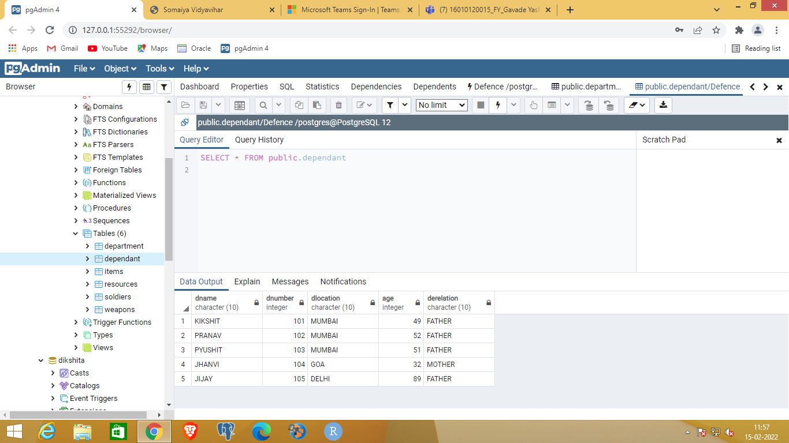

Code

CREATE TABLE DEPENDANT (DNAME CHAR (10), DNUMBER INT,DLOCATION CHAR(10) , AGE INT, DERELATION CHAR(10))

INSERT INTO DEPENDANT  
(DNAME, DNUMBER,DLOCATION,AGE, DERELATION )  
Values  
('KIKSHIT','101','MUMBAI','49','FATHER')

INSERT INTO DEPENDANT  
(DNAME, DNUMBER,DLOCATION,AGE, DERELATION )  
Values  
('PRANAV','102','MUMBAI','52','FATHER')

INSERT INTO DEPENDANT  
(DNAME, DNUMBER,DLOCATION,AGE, DERELATION )  
Values  
('PYUSHIT','103','MUMBAI','51','FATHER')

INSERT INTO DEPENDANT  
(DNAME, DNUMBER,DLOCATION,AGE, DERELATION )  
Values  
('JHANVI','104','GOA','32','MOTHER')

INSERT INTO DEPENDANT  
(DNAME, DNUMBER,DLOCATION,AGE, DERELATION )  
Values  
('JIJAY','105','DELHI','89','FATHER')

OUTPUT

